**Ballistic Velocity Variance**

Prepared for

Rabbit Creek Shooting Club

By Daniel Taylor

Request Date: March 1, 2023

Submittal Date: May 2, 2023

**Table of Contents**

**Introduction….…………………………………………………………………………………...3**

**Does Velocity Matter..…………………………………………………………………….....4**

**Data Gathering……………………………………………………………………………….....8**

**Finding Minimum Variance.................................................................10**

**Future Research..................................................................................14**

**Conclusion..........................................................................................14**

**Introduction**

DRT Consulting appreciates this opportunity to have been of service to Rabbit Creek Shooting Club (RCSC). Please contact us at 555-2390 if you should have any questions regarding the report or need further assistance. RCSC serves the community of Anchorage Alaska by educating youth and adults in firearms safety and recreation (Figure 1 shows the sign of RCSCs’ home range off the Seward Highway outside of Anchorage). DRT Consulting LLC has become the industry leader in providing key statistical analysis in the community for over 13 years. We have had the privilege of providing statistical consulting for many different sporting events. RCSC is hosting a rifle competition where each shooter will make a series of 500-yard shots. Each shooter will be firing the same make and model rifle with the same factory ammunition. RCSCs’ goal is to test the shooters’ ability to sight in and operate a rifle not their own while firing standard ammunition they may or may not be familiar with. RCSC has requested DRT to test the 4 available ammunitions to determine which one has the minimum variance in velocity. This is due to RCSCs’ belief that minimizing velocity variance will minimize the variance in bullet drop. Bullet drop refers to where the bullet strikes the target on the y-axis. The magnitude of the drop is not as important as the consistency of the drop. This minimizing will provide each competitor a fairer chance of being judged only on their skill as a shooter and not subject to the inconsistencies of the ammunition.

DRT Consulting LLC has identified variation in velocity as the primary contributor to the drop. DRT has also identified the ammunition that provides the minimum variance to be ammunition B: ***American Eagle 168gr OTM***with a mean velocity of **2,406 ft/s** and a variance of **300 ft/s** (standard deviation = 17.3 ft/s). DRT also found that the velocity variance may be significantly different from rifle to rifle. One other factor, ‘*shots fired since last cleaning*’ was found to be insignificant in this test.

Figure : Rabbit Creek Shooting Park (https://www.adfg.alaska.gov/index.cfm?adfg=anchoragerange.main)

**Does Velocity Matter?**

DRT Consulting LLC first wants to statistically analyze the importance that velocity plays in trajectory. Is there a legitimate basis for pursuing the variance in velocity? Projectile trajectories are governed by three main factors, Gravity (g), Velocity (v), and Drag (). For the purpose of this study, gravity is assumed to be a constant (g = 32.2 ft/s^2). Velocity and drag then are the varying components of a projectiles’ path. Drag is the force exerted on an object in the opposite direction of motion. When we initially approached this project, we assumed that a simple formula could be found to relate distance traveled, flight time, etc. However, solving for a complete analysis of projectile motion requires a application of differential equations. This is due in part because velocity and drag are changing throughout flight. A simplified formula for the distance traveled by a projectile starting parallel to the ground and assuming it “never” hits the ground is:

This simplified formula for distance is limited in scope considering all bullets will eventually hit the ground, the velocity is changing over time, and drag is not linearly related to velocity above the speed of sound (1,124 feet/s). A more complete model must be used in order to statistically define the variables in trajectory.

There are several free trajectory calculators that can be downloaded to alleviate the burden of doing trajectory calculations yourself. DRT Consulting LLC utilized ballistic software, ‘PointBlank Ballistics’ (PBB), the download can be found here: <https://www.huntingnut.com/pointblank.html>). The software is straightforward, and the complications of differential equations are automated. Figure 2 shows the graphical user interface. All other calculations and manipulations were performed in R (<https://cran.r-project.org>) and formatted in MS Excel.

Figure : PointBlank Ballistics GUI

The variables of interest are Ballistic Coefficient (BC), Velocity (Vel), Weight (Wt), Altitude (Alt), Zero Distance (constant at 100-yards), and Temperature (Tmp, °F). Published values for ammunition BC, Vel, and Wt can be found on the manufacturer’s website or with retailers. BC and Wt are also subject to variation but are outside the scope of this test. Table 1 has the published values for each of our tested ammunitions. The values of Alt=200ft, Tmp=30°F were actual range day values.

To test the effect of changing input variables on ballistic drops, DRT set a ‘Base’ equal to the ammunitions published values (Table 2 has the values used for the test, ammo ‘A’). Then each input was varied by +/- 10%. DRT created a table of all permutations of these values. This was done for the 3 values of each of the 5 inputs equaling = 243 possible combinations. DRT selected a random sample of 20 from this table and used PBB to calculate bullet drop at 500-yards. Table 3 has the complete table for analysis of inputs on ballistic drops.

Table : Published specifications for selected ammunition



Table : Ammunition 'A' Input Parameters for test



Table : Sampled data from Ammo 'A' permutation table



The sampled data revealed the impact of each of the inputs on the bullet drop. Figure 3 shows the impact of Velocity and BC on bullet drop. Drop is inversely proportional to both Velocity and BC. Velocity and BC do not appear to be independent. As the Velocity increases the effect of BC appears to decrease.

Figure : Effect of Velocity and BC on Bullet Drop calculation

DRT tested the significance of each input using a linear model and a method called Analysis of Variance (ANOVA). These statistical tools allow DRT to make decisions on what model will be best for analysis. DRT key initial assumptions:

1. Bullet drop is equal to a linear combination of all the inputs.
2. Residuals are normally distributed.
3. Constant variance

There are several tests available to ensure each of these assumptions holds true. For simplicity, the assumptions are held consistent. Below is the linear model that was incorporated:

Each of the β’s are coefficients for the independent variables. is the intercept term. Additionally, there is also an interaction (Vel * BC) between velocity and the ballistic coefficient. When the model is run in R (using the lm() function), the coefficients are found to be:

Figure 4 is a plot of the Ballistic Drop on the x-axis and residuals on the y-axis. An ideal model will have all residuals normally distributed around the zero line with a constant variance. DRT finds the normality, and variance assumptions sufficiently satisfied.

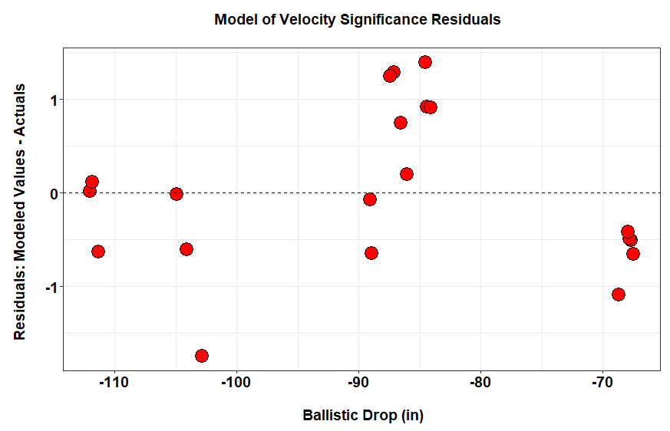

Figure : The model checking for significance velocity has residuals that are not normal. However, the minimal deviation from normal is accepted

Now that the linear model is generated, variables that are “significant” can be isolated using ANOVA. For these purposes, a 99% confidence value is utilized to determine a variable is informative before it is employed it in the model (the most *parsimonious* model is ideal as it provides the best answer at the lowest cost). ANOVA begins with a Hypothesis that none of the inputs to the model matter. Then for each input the Degrees of Freedom (Df), Mean Squared Error (MSE), F-Value, and the F distributions tail probability are generated. A web search of ANOVA is a great start to understanding the workflow. DRT Consulting LLC suggest starting at the site Guru99 (<https://www.guru99.com/r-tutorial.html>) and selecting the R ANOVA Tutorial under the Data Analysis section.

Table 4 is the ANOVA summary table. Observe in the ANOVA table that there is not sufficient evidence to conclude Velocity, Ballistic Coefficient and their interaction are insignificant at the 99% level. **Therefore, pursuing the minimization of velocity matters.** While the pursuit of minimizing the variance of the Ballistic Coefficient would also be valuable, that is outside the scope of this study. DRT recognizes the remaining inputs are important in a thorough study of projectile motion but given the data we have and the 99% level set, they are insignificant.

Table : ANOVA table for test of significance of model inputs



**Data Gathering**

RCSC’s request is test the 4 available ammunitions to determine which one has the minimum variance in velocity. Ballistic velocity can be measured with a Ballistic Chronograph. A *V3 Barrel Mounted Ballistic Chronograph* (Figure 4) was acquired from the RCSC team for use in the data gathering ( <https://magnetospeed.com/products-v3-ballistic-chronograph> ). This chronograph mounts to the barrel of the rifle and incorporates “patented electromagnetic sensor technology” and it has a published “accuracy between 99.5% and 99.9%” (find at [www.magnetospeed.com](http://www.magnetospeed.com), Support, MagnetoSpeed General FAQ’s, Tags V3). Each round passes ~0.25 inches over the top of the chronograph and the velocities are recorded on the digital display (Figure 5).

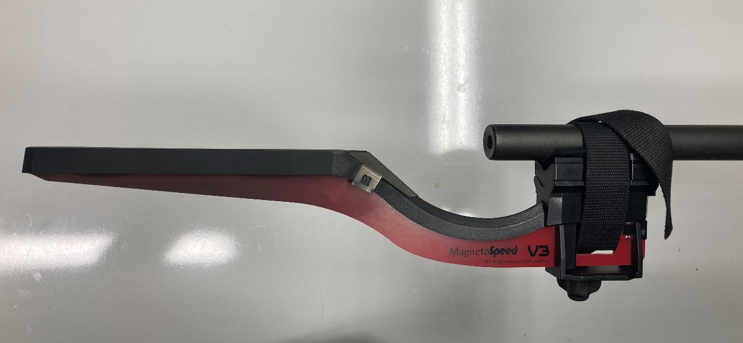

Figure : MagnetoSpeed V3 Ballistic Chronograph

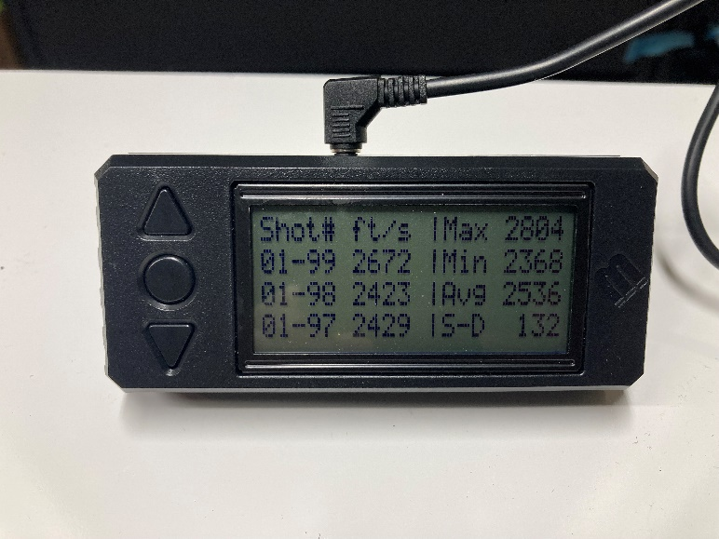

Figure : MagnetoSpeed V3 Digital Display Box

Two rifles of the same make and model were selected (make and model not provided but have 16.5in barrels). Both rifles were cleaned appropriately prior to testing. Thirty rounds for each of the 4 ammunitions were used in this study. The 4 ammunitions (labeled A, B, C, D) were repeated for 64 shots in Rifle-1 and 44 shots in Rifle-2. The desire was to perform what is known as a Completely Randomized Design (CRD) with the same number of shots from each ammunition out of each rife on the same day. The weather was an unforeseen potential variable. The first day started out at 30°F and then dropped to 20°F and the wind picked up. This forced a second day to test Rifle-2. The range was busy on this day, and sunlight diminished before all shots could be taken. After looking at the quality of data, it was found the sample size was adequate. See Table 5 for the complete set of recorded velocities. Notice in Rifle-2 → Ammo ‘A’ → Shot #1 is crossed out. This shot for ammo ‘A’ falls almost 300 ft/s shy of the anticipated mean for this ammunition. The only explanation is that this bullet was not ammo ‘A’. It will not be used in the analysis.

Table : Recorded velocities over two days of testing



**Finding Minimum Variance**

The velocity data demonstrated a statistical significance between ammunition types. Looking at Figure 7, four well distinguished populations are observed. There is some overlap between the velocities of ammunition B and C. Significant difference between the two is present. Figure 8 displays the data split by Rifle 1 & 2. There appears to be an effect attributed to rifle but statistically unjustified, and is discussed in the model section. Figure 9 shows the effect of shot number on velocity. The velocity average does not change significantly over the shot counts measured. Figure 10 displays the effect of ammunition on velocity. A distinction in average velocity between ammunition choice is present. The boxplots also show a difference in the variance of each ammunition.

*Figure 8: The median of Rifle-2 appears to be lower than Rifle-1*

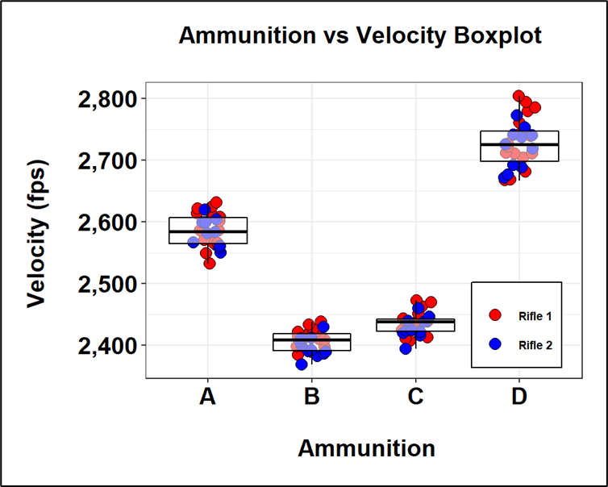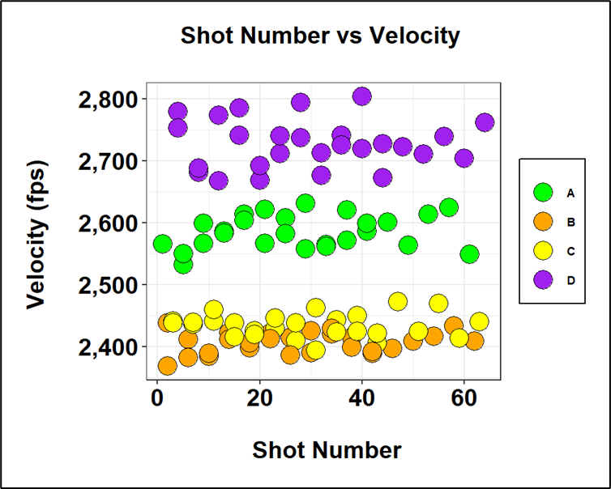Figure 7: A clear distinction between ammunitions can be observed

Figure 10: It is clear from the above boxplot that velocity and variance are unique within each group

Figure 9: The mean value for each ammunition does not appear to be changing with shot number

Each ammo type appears to be normally distributed, but confidence is needed prior to addressing the differences in variance. Figure 11 is known as a QQ Plot (Quantile-Quantile plot). Here each ammunition group is assumed to be normal. The mean and standard deviation of each group are calculated. Then each velocity value is linked to its corresponding Z-score value. This Z-score is the value on the x-axis of the normal distribution with a mean of 0 and a standard deviation of 1. The formula for determining the Z-score value is:

If the distribution of the Velocities is normal, then there will be a strong linear relationship in the plot within each ammunition group. This is present in Figure 11. In addition to this graphical method, a Shapiro-Wilk test can be run. This test starts with the Null Hypothesis: the data is normal. Then it calculates what is known as the W-statistic and associated p-value. Large p-values (>0.05) mean that you cannot reject the null and the data is normal. The Shapiro-Wilk involves some lengthy calculations but again, there are many great resources on the web to learn more. If interested in performing the test programmatically in R, <https://www.geeksforgeeks.org/shapiro-wilk-test-in-r-programming/> provides a great explanation. Table 6 is the summary of the Shapiro-Wilk test. Each p-value is very high indicating we can be confident the ammunitions come from normally distributed populations.

Table : The Shapiro-Wilk Test for testing a datasets normality



Figure 11: QQ plot of Normal Z-scores with their corresponding velocity values for each group

Considering Figure 11, each ammunition has a distinct mean. As shown before, ammunition B and C appear as though they might be indistinguishable from each other. The difference in all group means was tested using the Tukey-Kramer test (TukeysHSD function in R). This test analyses the differences in the means between all possible pairs of facors present. Confidence intervals for the differences are calculated. The conditions for performing the Tukey-Kramer are:

1. Randomly sampled points
2. Normally distributed populations
3. Homoscedasticity

Equal variance is not present among our 4 ammunitions but the test is robust in handling some variation of variance. Performing the Tukey-Kramer test by hand with unequal sample sizes can be tedious and time consuming. Software makes the Tukey-Kramer accessible. If you would like to perform the test in R, a great resource can be found here: <https://whitlockschluter3e.zoology.ubc.ca/Tutorials%20using%20R/R_tutorial_ANOVA.html> . The results of the Tukey-Kramer Test can be seen in Figure 12 and Table 7. On the x-axis are all possible pairs of ammunition. On the y-axis are the mean differences between the pairs of ammunition. The outer bounds of each box represent the 95% confidence intervals on these differences. If a confidence interval extends over zero, then the means are not statistically different. In the dataset, no confidence intervals cross over the zero line. Therefore, each mean is unique at the 95% confidence level. Ammunition C and B then do not share the same mean.

**Tukey – Kramer Test of Mean Difference**

Table : Results of the Tukey-Kramer Test. Note that the lower bound of the C-B pair is close to 0



Figure 12: Tukey-Kramer results for the mean differences in velocities between ammunition. All pairwise comparisons are significant

Each ammunition has a normal distribution of velocities and those distributions are distinct as statistically demonstrated. DRT Constulting can move forward with looking at the different variables and asess which one has the minimum. Table 8 contains the summary of ammunition mean, standard deviation and variance. **The minimum variance among the available ammunition is ammunition B: American Eagle 168gr OTM.** Figure 13 is a graphical display of the results. As the mean velocity increases, variance increases. Figure 8, Rifle Vs Velocity Boxplot presented a slight difference in overall mean velocities between the two rifles used. Because the two rifles were fired on two separate days, with two different chronograph configurations, it would be impossible to distinguish the effect of the rifles themselves.

Table : Velocity variance summary.



Figure 13: Relationship between the Mean velocity values and variance between groups

**Future Research**

A more complete model of the ballistic trajectory includes, but is not limited to the following factors:

1. Powder Type
2. Powder Charge
3. Primer Type
4. Casing Type
5. Bullet Weight
6. Bullet Shape
7. Bullet Cross Sectional Area
8. Rifle Type
9. Barrel Length
10. Barrel Twist
11. Air Pressure
12. Moister Content
13. Drag Coefficient
14. Ballistic Coefficient

Many of these factors are manifest in the velocity term. DRT Consulting LLC would like to pursue aggregating all of RCSCs available reloading and performance data to provide a more thorough report of key performance indicators.

**Conclusion**

Once again, DRT Consulting appreciates this opportunity to have been of service to Rabbit Creek Shooting Club (RCSC). Please contact us at 555-2390 if you should have any questions regarding the report or need further assistance. RCSC requested DRT to test the 4 available ammunitions to determine which one has the minimum variance in velocity. DRT Consulting has identified the ammunition that provides the minimum variance to be ***American Eagle 168gr OTM***with a mean velocity of **2,406 ft/s** and a variance of **300 ft/s** (standard deviation = 17.3 ft/s).